Susan Abbott
Plein Air Landscape Painting Supplies
General supplies:
Layered clothing for damp or cool weather. Sunhat, bug spray and sunblock.
Sketchbook small enough to carry easily for notes and sketches in field
Pens or pencils for sketchbook (Faber-Castell Pitt pens black work well)
An art bag or small backpack or caddy for carrying painting supplies. You’ll want to be able to move around comfortably with your gear and fit in a carpool.. Practice your packing and set-up at home.
Water bottle for drinking, and extra bottle if working in watercolor
A plein air easel and/or portable stool (see easel information below)
An Easel umbrella will give you more flexibility on where to set up. (I use a Best Brella, but they are out of business)

WATERCOLOR
Arches or another good brand watercolor block, or watercolor paper minimum size 12”x15”, approximately 15 cut sheets, 140 lb. cold-pressed paper suggested. (You won’t be happy with the poor quality of student grade or Strathmore paper for your plein air paintings.)
2 pieces of foam core a little bigger than watercolor paper, sandwiched around watercolor paper if you don’t have a block (you can use these as a support--even if you have a block, bring a support like a piece of foam core so you can have more than one painting going at a time)
Masking tape (not blue painter’s tape, throws off your color. I like white "Pro artists’ tape")
Brushes in a protective case (3 or 4 rounds and flats, not too small)
https://www.dickblick.com/products/alvin-prestige-paintbrush-holders/
Robert Simmons Sienna series are an affordable choice:
http://www.dickblick.com/products/robert-simmons-sienna-brushes/
Pencils, erasers, sharpener (I use H or HB pencil for drawing under watercolor)
Roll of paper towels or cotton rags
Pikes palette or similar type, filled with dried watercolors (make sure you give your palette at least a few days to dry with the cover off. See attached suggested color placement if you are starting a new palette.)
Extra tubes of your most used colors (put in a sealed baggy in your luggage.)
Water holder
Viewer:
http://www.dickblick.com/products/viewcatcher/
Suggested watercolors:
You don’t need to refill your palette with these colors, but below are pigments I use and teach with. Brands are Winsor Newton (WN), Schmincke (SCH) and Daniel Smith (DS). No abbreviation after the pigment means any brand professional grade paint will do. See end of this doc for instructions on how to fill a new Pikes Palette.
Most important colors have asterisks.
*cadmium lemon or lemon yellow
cadmium yellow pale
*hansa yellow medium (DS)
cad orange or Pyrol orange (DS)
*cadmium red (light or middle, not deep)
quinacridone coral (DS)
*permanent alizarin crimson
*permanent rose (WN)
*ultramarine blue (or “French Ultramarine”, NOT “green shade” or “red shade”)
*cerulean blue (SCH helio cerulean is less opaque than WN)
cobalt blue (expensive but great for skies-I like Schminke cobalt blue light)
*prussian blue or thalo blue or winsor blue (not “red shade”)
*yellow ochre or raw siena or quinacridone gold (DS)
chromium oxide green brilliant (Sch)
*burnt sienna or quinacridone sienna DS (redder than regular burnt sienna)
burnt umber
naples yellow

OIL
You’ll need 2 canvasses a day if you are working only in oil or acrylic, and they can be sized from around 10” x 12” to 14” x 18”. Squares are also fine.
Gessoed linen panels are a good choice. I use Raymar panels available at: http://www.raymarart.com.
I'd suggest laying a light burnt sienna ground on your canvasses before the workshop. To do this, mix burnt sienna pigment and solvent on your palette, brush lightly on the panel or canvas, and rub off with a rag. Allow a few days to dry. The result will be an even toned, light or middle value warm brown.
Selection of oil brushes in assorted sizes, disposable palette, rags, palette cups, brush cleaner or bar of soap.
Protective brush case like this one: https://www.dickblick.com/products/alvin-prestige-paintbrush-holders/
You can hold in hand a paper palette, or a wooden palette. With a French easel, you can use a Masterson palette with a lid, balanced on the open drawer. Insert a paper disposable palette inside.
http://www.dickblick.com/products/masterson-super-pro-palette/
Medium: Galkyd by Gamblin (dries quickly), or linseed oil, or mixture of 1/3 linseed oil, 1/3 damar varnish, 1/3 gamsol, or ½ Gamsol and ½ linseed oil (what I use). I keep my medium in a pint jar with a secure top and pour it out daily into a solvent cup clipped to my palette.
Solvent: odorless, such as Gamsol (if not flying, if you are, the workshop will supply) in a secure solvent jar
Safflower oil and Ivory Soap work well for cleaning brushes.
Suggested oil or acrylic pigments:
Zinc/Titanium White
Naples yellow
Yellow ochre
Cadmium yellow pale
Cadmium lemon or lemon yellow
Cadmium red med or light
Permanent Alizarin crimson
(Permanent rose optional)
Ultramarine blue
(Cobalt blue optional)
Cerulean blue or Manganese blue
Prussian blue
Burnt sienna
Burnt umber
If working in oils: If rainy we will do studies in the studio. Oil painters should bring a small set of gouache OR watercolors, a palette, watercolor brush, and some watercolor paper for these indoor exercises.
Gouache colors for oil painters: lemon yellow or spectrum yellow, primary red or other warm red, perm. alizarin crimson, ultramarine blue, pthalo blue or winsor blue, perm. white.
Example of gouache watercolor palette: https://www.dickblick.com/products/blick-folding-palette-box/
Example of watercolor paper for gouache: http://www.dickblick.com/products/strathmore-400-series-watercolor-paper-pads/
EASELS
You'll need an easel for outside work in both oils and watercolors.

For watercolors I use the Plein Air Pro watercolor easel, which is lightweight and well-designed.
https://enpleinairpro.com/collections/packages
For oils I use a “half French” wooden easel:
http://www.dickblick.com/products/plein-air-easels-by-jullian (I also use this for watercolors if bringing just one easel for both oil and watercolor)

Make sure you get the half-easel, as the full models are too heavy for outdoor work. Do not get a cheaper brand of wooden easel, as they break easily if not well-made.

You can also use a pochade box for smaller oils, which integrates a paint box, palette, and easel, and is usually put on a tripod.
http://www.artworkessentials.com/
Another popular pochade company:
https://www.judsonsart.com/collections/pochade-boxes
We won’t be hiking in to painting sites but will be carpooling. Have your supplies compact and well-organized, try out your easel at home before the workshop, to make sure you have a workable system (ie., where do you put your water and palette, or solvent?)
Please feel free to call (802-454-1621) or email me at sa@susanabbott.com with any supply or packing question.

Scan down for photos of my set-ups.
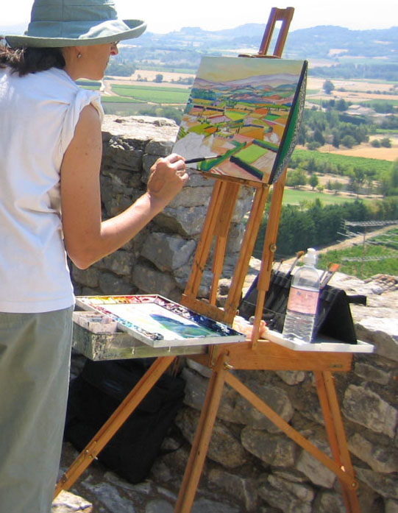

This is a half French easel that I use for both watercolors and oils (I also use the Plein Air Pro watercolor easel https://enpleinairpro.com/collections/packages/products/advanced-series-watercolor-package)

I have a Pikes Palette balanced on the open drawer, with Holbein watercolor cups wedged in for stability. An Arches block or watercolor board are needed as a support for paper.
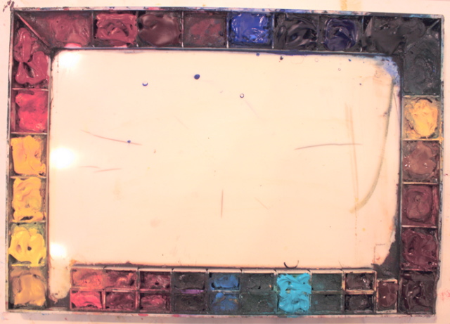

Filling your Pike’s palette:

The idea is to lay out your palette like a color wheel, going from yellows to warm red, then turning the corner to cool reds, violets and blues, then turning the corner to greens and earth colors.

Start with naples yellow on the left (have the empty side of palette facing you) then aureolin, cadmium yellow pale, cadmium yellow, then any other yellows, cadmium orange, any other orange, cadmium red, quinacridone coral if you have it. Stop at the corner with a warm red (like cadmium red or quinacridone coral.)

Then turn the corner and fill the next stall with alizarin crimson (a cool red), perm rose, red-purple like perm magenta, blue-purple like Winsor violet, then ultramarine blue, cobalt blue. Then your green-blues, like cerulean, cobalt turquoise, and finish with prussian or thalo blue.

On the right-side start stalls with viridian or Winsor green, and any other greens you have, then earth colors like yellow ochre, quinacridone gold, burnt siena, and burnt umber.

Fill the stalls up to the top and leave the lid off to dry for a few days. You may want to bring tubes (in your checked suitcase if flying) of your most used colors (like ultramarine, Prussian, alizarin, or aureolin) to restock your palette during the workshop. Note that I fill stalls to the top, so I have plenty of pigment to work with.

Skip spaces where you might want to try some new colors. If you run out of stalls, you can buy a bag of Schmincke brand empty stalls from Dick Blick supplies, and glue them on the empty side of the palette.

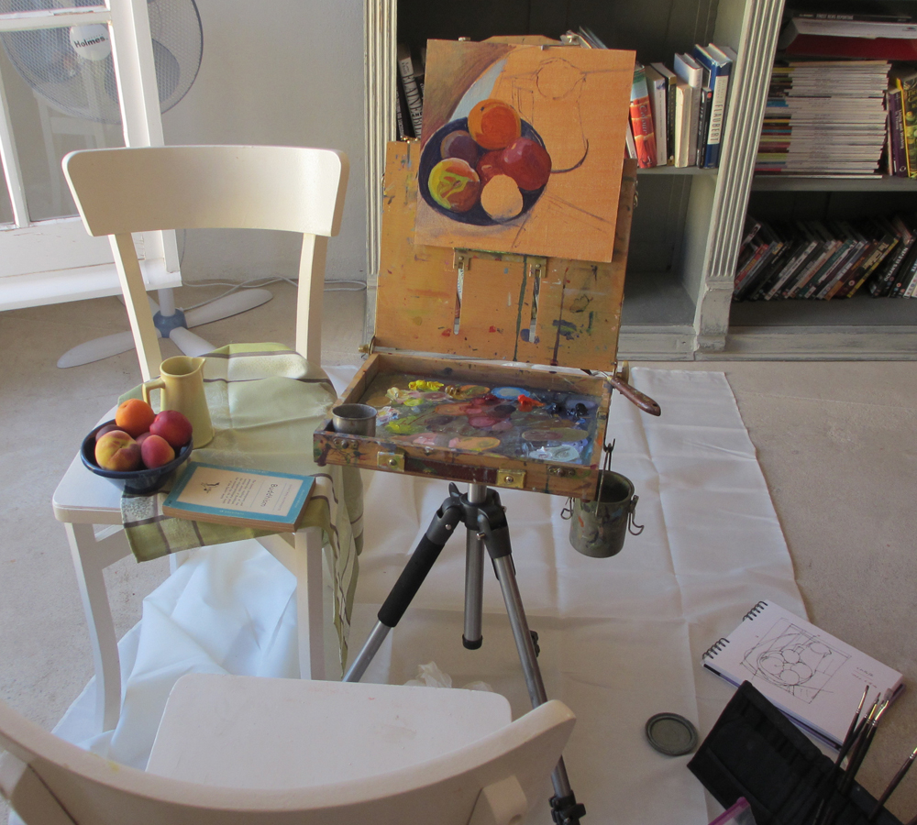

This is my Pochade box set-up. I’m using a Raymar panel I’ve toned with Burnt Sienna thinned with Gamsol and then let dry. Glue a thin piece of glass or plexiglass into the pochade box for a palette, that’s much easier to clean than the wood surface the box comes with.

This box is from http://www.artworkessentials.com/ , it’s well-made and I’ve been happy with it. Note the solvent can hanging from a clip that you can buy with the box.
When using a French easel or pochade box, I carry supplies separately in a backpack to keep the box weight more comfortable.

