The Definative Print
www.patpauly.com/
piecesandresistance.blogspot.com
questions: PatPaulyart@gmail.com
www.patpauly.com
www.piecesandresistance.blogspot.com
Questions? email PatPaulyArt@gmail.com
Pat Pauly Workshop

Level: Intermediate / advanced. Some knowledge of dye mixing and processing is needed for this class.
Materials Fee: $70 payable to Pat at class

About the Workshop The Definitive Print
Join Pat Pauly for this five-day workshop where we print large scale fabric throughout the week with an focus on well defined motifs that play off each other in scale, color, shape and texture. With a myriad of printing techniques using fiber reactive dye on fabric we’ll print over five days in layers that range from subtle to bold. Silk screen, monoprint, rubbings, stencil – along with a few more techniques – are used to print cloth that can be used whole, pieced or in apparel. This class is for those already experienced with printing, and is designed for intermediate or advanced printers. Our goal is to print defined motif additions, in layers or multiples, for large graphic compositions.
About Pat Pauly
A sought-after lecturer and teacher in contemporary fiber arts, Pat Pauly shares her wealth of knowledge from decades of working in design. Recognized nationally and internationally, her work evokes natural forms that are bold and graphic. Her award-winning art quilts have been featured in numerous publications and exhibitions. Her workshops focus on design and technique, as well as when to apply the rules, and when to toss them out. Pat Pauly’s studio is in Rochester, New York.

Materials List
- Old clothes to wear, apron, rubber gloves
- Old towel, cut apart to washcloth size (about 4 small sized cloths) .
- Optional Medium sized bucket (2 gallon or so)
- one small (4”) high density foam roller (the type used to paint walls) optional large roller, nappy kind for monoprinting
- 3 wide plastic scrapers, my favorite – Bondo brand spreaders, used for spreading “bondo” auto resin body filler, or “Roman” brand wallpaper smoothing tool (Amazon/wall paper stores.)
- 9 spatulas, or tall wooden spoons – for stirring the dye (need long handles) No Paint Sticks
- Roll of blue masking tape
- Roll of Duct tape for taping silkscreens, or tape meant to tape out silkscreens )(dick blick)
- A sharpie marker, 10 sheets of plain copy paper
10 yogurt or plastic containers (quart size is best) no wide containers, with lids
- Optional -- 1 small squirt bottle with small hole nozzle. Pat will have some to use.
- 6 sheets of newspaper
- Scissors to cut cloth
- Optional table risers (or bed risers) to elevate the printing table optional if you want. There are some available at the workshop
- Notebook, pencil/pen, camera / phone camera
- Things for printing: 2 to 3 Stencils, cutouts, a few yards of clothesline or other rope/string. Don’t buy anything, just look for objects that are slightly raised surface. Thicker plastic things for rubbings
- Silk screens: (2 - 3) 16” x 20” or similar (order from Dick Blick wooden framed ones http://www.dickblick.com/products/blick-cord-stretched-frame-with-110-monofilament-polyester-mesh/) or purchase from Pat at workshop for $35
- Fabric: 15 yards minimum, cut in 4 at ½ and 11 or more 1-yard pieces (feel free to bring more like 20 -25 yards) of PFD 100% cotton, I use Test Fabrics #419 or #400M. (Call for prices and availability at testfabrics.com.) You can also use predyed prepared for dyed (PFD) fabrics, and linen. Just make sure that they are 100% cotton or linen, and prewashed to remove the finishing materials added to the fabric. You can also soda soak other cotton, linen, lightweight canvas, predyed cottons for experimentation. Avoid commercial prints, even those that are white on white. If the fabric is sold as pdf, I do not prewash before soda soaking.

Before Class
- Watch the videos on my blog on computer not phone (www.piecesandresistance.blogspot.com) for soda soaking, printing. At the bottom of the blog’s is a large group of words, search for “video” for all the videos
- Prepare fabric for printing by soda soaking. Step one is not optional.
  - Add a tyvek tag with your first name and last name written in sharpie. Sew a Tyvek label on the corner. But this has to be sewn on BEFORE SODA SOAKING. You would not want to sew through soda-soaked fabric, as it will damage your sewing machine. Do not pin or staple. Tyvek is a plastic type of mailing material, also used for house wrap in building construction. These tags should hang off one corner, must be larger than 2” x 4”.
  - Soda Soak Make ahead of class, soda soak your fabric. Wear gloves for this. In a large bucket add two-gallons water to two cups sodium carbonate (soda ash), add fabric (about 2-3 yards) loosely to this solution and soak 15 minutes or more. Ring out, hang on a line to dry, do not dry in dryer. Continue with small batches until all your fabric is soda soaked. One great tip: after fabric has soaked, place in a sink (or bathtub) to drain a while or overnight, then hang on line to dry. No drip!
  - You can make the soda soaked fabric way ahead of time. You can reuse the solution over and over. I’ve stored cotton for a year to wait to use it. So, do a few at a time, not in the washing machine, just in the bucket, drain, hang, store. Note: drying in dryer may cause a fire.
  - Note: I purchase my soda ash from pool supply places. I make sure it states “100% soda ash” on the label.
- Graphic Notes
Keep a notebook ahead of class of simple forms, shapes, patterns and images that you want to use in your work. You need to have reference for the marks you will be using. Keep a Pinterest board, a box of images, or handful of sketches you can readily access to pull graphics. This is both for jumpstarting your prints, also for starting your OWN mark for a series of prints. Black paper and scissors are a great warmup for exploring the relationship of objects in the composition.

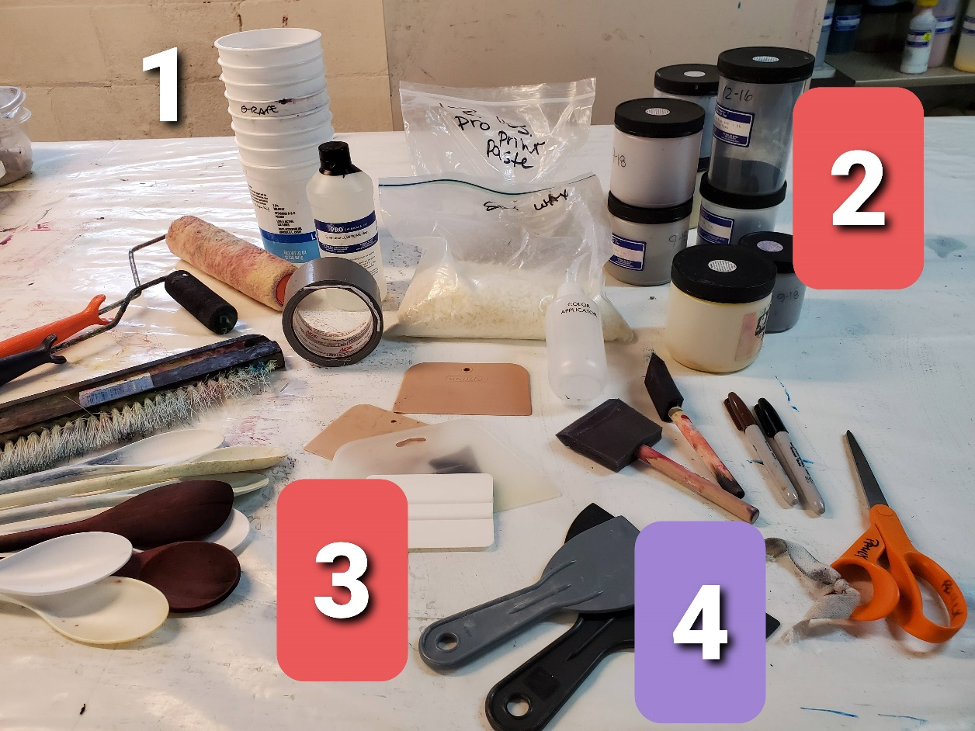
- Directly below are two rollers (one foam, one not). These are wall painting type.
- Upper middle (in plastic baggies) is pro print paste, dyes, and soy wax. These will be supplied by Pat ready at the class. They are included in the materials fee collected in class.
- Bondo scrapers (flesh color, no handle) or other types. Lower left is long handle spoons. I like the white plastic (middle of the bunch) best. Left hand side is a long wallpaper brush I use for monoprinting (optional)
- Scrapers like large plastic putty knives leave home! This is an old photo!
Feel free to email me (patpaulyart@gmail.com) with any questions. I look forward to our Workshop!

